ICEIRD2009: International Conference for Entrepreneurship, Innovation and Regional Development Guidelines for the Submission of Papers
Anna Sotiriadou¹, Petros Kefalas²
¹City College, 13 Tsimiski Str, Thessaloniki, Greece, sotiriadou@city.academic.gr
²SEERC, 17 Mitropoleos Str, Thessaloniki, Greece, kefalas@seerc.org
The abstract should be around 150-200 words and definitely fit in the first page of the paper. This document is a sample document that gives the authors of ICEIRD 2009 a general overview of how their camera-ready paper should look like. This paper will be included in the Proceedings of the Conference. The document is based on the styles created in the template available form the site of the Conference.
Keywords
Up to 5 keywords arranged in alphabetical order formatting a paper (e.g. Clustering and networking, Entrepreneurship Education, Governmental and regional policies on entrepreneurship, innovation and R&D)
1. Introduction
In order to be able to produce a camera-ready paper like this one, you will find easier to use the template that is provided in the site of the Conference in http://www.seerc.org/iceird2009/. All camera-ready papers should be submitted to the secretariat of ICEIRD by email (iceird2009@seerc.org) in both Microsoft Word or PDF format. Please follow these guidelines as wrong formats will imply delays. All items in this document are defined as styles (see Format > Style..). It should be straightforward to format the document using those styles. Camera-ready papers should be from 6 to 10 pages.
2. Formatting Guidelines
Sections and subsections should be numbered 1,2,3, … and 1.1, 1.2, … etc respectively. Titles of sections and subsections should be in small caps except from the initial letter of every word. The following formatting guidelines also apply.
2.1 Text
All text written in paragraphs should be in Arial 11, with no intent and fully justified (left and right). If you need to put some emphasis in words, key terms etc. please use italics, for example this is an emphasised text. Do not use bold or other typeface.

2.2 Tables
You should present tables in your manuscript and should contain only horizontal rules. Each table needs a short descriptive title above it. Column headings should clearly define the data presented. If necessary, suitably identified footnotes should be included below. Take care to include all the units of measurement. The table needs to be cited in the text.
For example, the margins of the text are set as in Table 1. Use Page Setup to set the margins or the template provided. Make sure that the table caption is included after the table. Tables should be numbered 1,2,3, … etc. Tables and table captions must be centred. There is a special style for text within the cells of the table.

Table 1 Setup of margins for camera-ready paper.
Margin | Cm
Top | 2.5
Bottom | 2.5
Left | 2.5
Right | 2.5
Header | 1.25
Footer | 1
2.3 Figures
Figures and images must be centred too. Make sure that the figure caption is included after the figure or image. They should be numbered 1,2,3, … etc., as for example Figure 1.
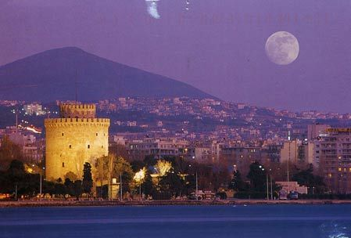
Figure 1 The city of Thessaloniki.
2.4 Bullets
If you need to use a bullet list then this should be as follows (the bullet is at 0.7 cm):
- Bullet item one, some text.
- Bullet item one, some other text.
etc.

2.5 Abbreviations
As far as possible, please avoid the use of initials, except for terms in common use. Please provide a list, in alphabetical order, of abbreviations used, and spell them out (with the abbreviations in brackets) the first time they are mentioned in the text.
2.6 Citations
Reference list. References should be listed in Vancouver style and numbered in the order in which they appear in the text. In the text, enclose reference numbers in square brackets, e.g. [1], [2], [3], … etc. That means that references should not be listed in alphabetical order. Please avoid using endnotes or footers.

References to Internet materials should be treated as other references in the text. In the reference list, they should be dated and sufficiently identified for readers to be able to find the material unambiguously.
3. Conclusions
Thank you for trying to format your paper in the way that this document describes. You will be notified for acceptance according to the dates specified in the call for papers. We are looking forward to seeing you in the Conference.
References
1 Fowkes F G R, Fulton P M. Critical appraisal of published research: introductory guidelines. BMJ 1991; 302: 1136-40.
2 Borrey D, Spencer H. OMR vs. Image based marks recognition competing technologies for the same market? http:/www.visionshape.com 1997 January

