MIGRATE POLICY PAPER
Edited by Dimitris Tsarouhas

Executive Summary
The migration and refugee crisis has had a profound and lasting effect on the European Union. It occurred in the aftermath of the economic and financial crisis and has run a parallel course with the Brexit debate. In that sense, it has reinforced centrifugal tendencies within the Union and raised fears of disintegration as a result of the lack of solidarity among member states and the realization that a common EU-wide policy on asylum and immigration remains an aspiration rather than a reality.
In the short-term, the crisis has benefited nationalist-populist parties, whose securitized discourse over migrants and refugees allowed them to reinforce widespread, but often unfounded, popular fears as to the intentions and cultural ‘fit’ of migrants in European societies. Finally, the response to the crisis by national governments has been shaped by the interaction of their domestic and EU-related priorities. While some (Hungary) embarked on the politics of rejection and intransigence to reinforce their domestic political discourse, thereby ignoring the EU factor, others (Greece, Turkey, Serbia) adopted an accommodating and welcoming stance primarily (though not exclusively) with an eye on EU-wide developments, wishing to ‘Europeanize’ the migration and refugee crisis. Conjunctural, ideological and interest-driven factors are intertwined in explaining the response by member states and candidate countries alike.

Introduction: The Migration Crisis in Context
In 2015, the European Union (EU) was in the midst of unprecedented challenges. The spread of the Eurozone’s economic and financial crisis had stopped, but austerity and sluggish growth was inflicting heavy damage on member states, especially in the periphery. Recriminations between northern and southern member states cast doubt on the future of the EU and facilitated the rise of nationalist and populist forces. Self-doubt and the populist Zeitgeist made the Union hostile to the prospect of further enlargement: the new Commission led by Jean-Claude Juncker had made it clear that no countries would be joining the club at least until 2019. Meanwhile in the UK, the victory of the Conservative Party in the general election paved the way for the divisive referendum on EU membership that would take place a year later.
Therefore, when the migration and refugee crisis hit Europe, it was already plagued by uncertainty, self-doubt and division. What role has the migration issue played in the process of European (dis)integration? How have member states and candidate countries sought to steer their policy in response to this issue, and to what end? Finally, how should EU policy makers respond to the current challenge pertaining to migrants and refugees and what lessons can be learned from past experience?

Results I: Securitizing A Complex problem
Our project findings point to the fact that EU member states and candidate countries alike have, for the most part, interpreted the influx of migrants and refugees as a security question. Governments and political leaders have talked up the possibility of terrorist attacks resulting from the entry of hundreds of thousands of refugees, and embarked on border control initiatives and proclamations of dubious legitimacy and little practical effect. Although only few have gone to the length of Hungary’s Victor Orban, whose portrayal of refugees as potential terrorists, not least due to their Muslim religion, has become the cornerstone of his political strategy, most have played into the hands of a nationalist and divisive discourse. The reasons behind this

choice are straightforward: fear and insecurity gripped most Europeans as they watched caravans of destitute people desperately seeking to cross the Balkan corridor towards Western Europe or seeking to cross the Aegean Sea. Yet securitization cannot be a long-term strategy for a European Union who wishes to invest in its soft power appeal and which depends on its attractiveness to outsiders to boost economic growth and maintain social harmony among all of its inhabitants. The hard work of seeking to de-securitize the issue and offer options for a rational, facts-based dialogue on the question of immigration and its complexity fell on the hands of few political leaders, the best example of which was and remains German Chancellor Merkel. The limited success of the de-securitization attempts point to the need to double down on such efforts and deal with the migration issue from an entirely new basis.

Results II: Domestic Politics First
A truly EU-wide approach to the crisis, involving candidate countries and seeking to engage in burden-sharing, has been absent throughout. Instead, governments have engaged in predominantly domestic political calculations in adopting their policy stance on the issue. For candidate countries such as Serbia and North Macedonia, adopting a policy stance conducive to their EU aspirations was a potential vote-winner as well as a low-cost policy, given the small number of refugees wishing to settle in their respective territories, For Greece, the welcoming approach by the SYRIZA government sought to strike a political tone different from the ‘law and order’ agenda that the previous administration had been identified with. Lastly for Turkey, the agreement with the EU underlined its salience in dealing with the issue and demonstrated to the Turkish public the tangible financial and political benefits that Turkey can reap through its ‘welcoming’ stance. Considering that such domestic policy considerations preoccupied most member states outside the scope of our project points to the main reason behind the failure of the voluntary humanitarian readmission scheme. The paltry numbers of refugees who have been part of the scheme to date, in sharp contrast to the grand promises made by EU officials at the time of the scheme’s launch, reveal the gap between rhetoric and practice. What hides underneath that gap is a steadfast refusal to couch a response to the challenge in EU-wide, comprehensive terms that will design and implement an migration policy for the long run and in line with the Union’s rhetorical commitment to solidarity, aid and sustainability.

Policy Recommendations
1) A New Discourse on Migration. Agreements with third countries to regulate the flow of migrants to the European Union can be beneficial. The EU-Turkey Agreement is a case in point. Nevertheless, such agreements will help the EU manage migration in a long-lasting, sustainable manner only if this complex and multifaceted issue is effectively de-securitized. The current approach has reached an impasse: by securitizing the issue the Union has done little to calm the fears and insecurities of its citizens while simultaneously yielding precious political ground to xenophobes and zealots.
We recommend a new political discourse on migration built on three pillars: a) migration is neither new nor spectacular. The overwhelming majority of migrants are in search of a better life for themselves and their families, as migration flows are bolstered by climate change and inequality b) the security of each and every EU citizen is a priority and all measures to boost it are taken, regardless of migration c) the EU stands to gain economically and socially from an ordered and open migration policy that acknowledges the challenges associated with it.

2) A Common European Asylum System redesigned. Discourse and policy go together. The obstacles towards a common asylum system are formidable but reaching that point is a sine qua non for a truly European approach. Intergovernmentalist attempts are by definition short term and make the management of migration harder still, as the collapse of the Dublin Convention demonstrated. The Common Asylum System has been tried and tested during the crisis and its shortcomings range from differentiated national procedures on asylum claims to waiting times and lack of coordination with key stakeholders. Given the scale of human movement expected in the years to come, overhauling the system to make it compatible with EU integration, not least the Schengen system, is imperative.

3) A Credible Enlargement Process. Until the ‘big bang’, enlargement was celebrated as a great EU success. Making sure that the western Balkans maintain their EU orientation and undertake the reforms that align them closer to the acquis is today a geo-political issue for the Union. In the midst of anti-western sentiments rising, and the generous support offered to such endeavors by major powers, it becomes imperative that democratic political forces are encouraged in the region and their prospects for EU membership encouraged. The EU already suffers from a credibility problem in the region: advocating leaders and administrations that rhetorically commit to membership but undermine democracy in practice erodes EU legitimacy and encourages further trouble in a volatile region.

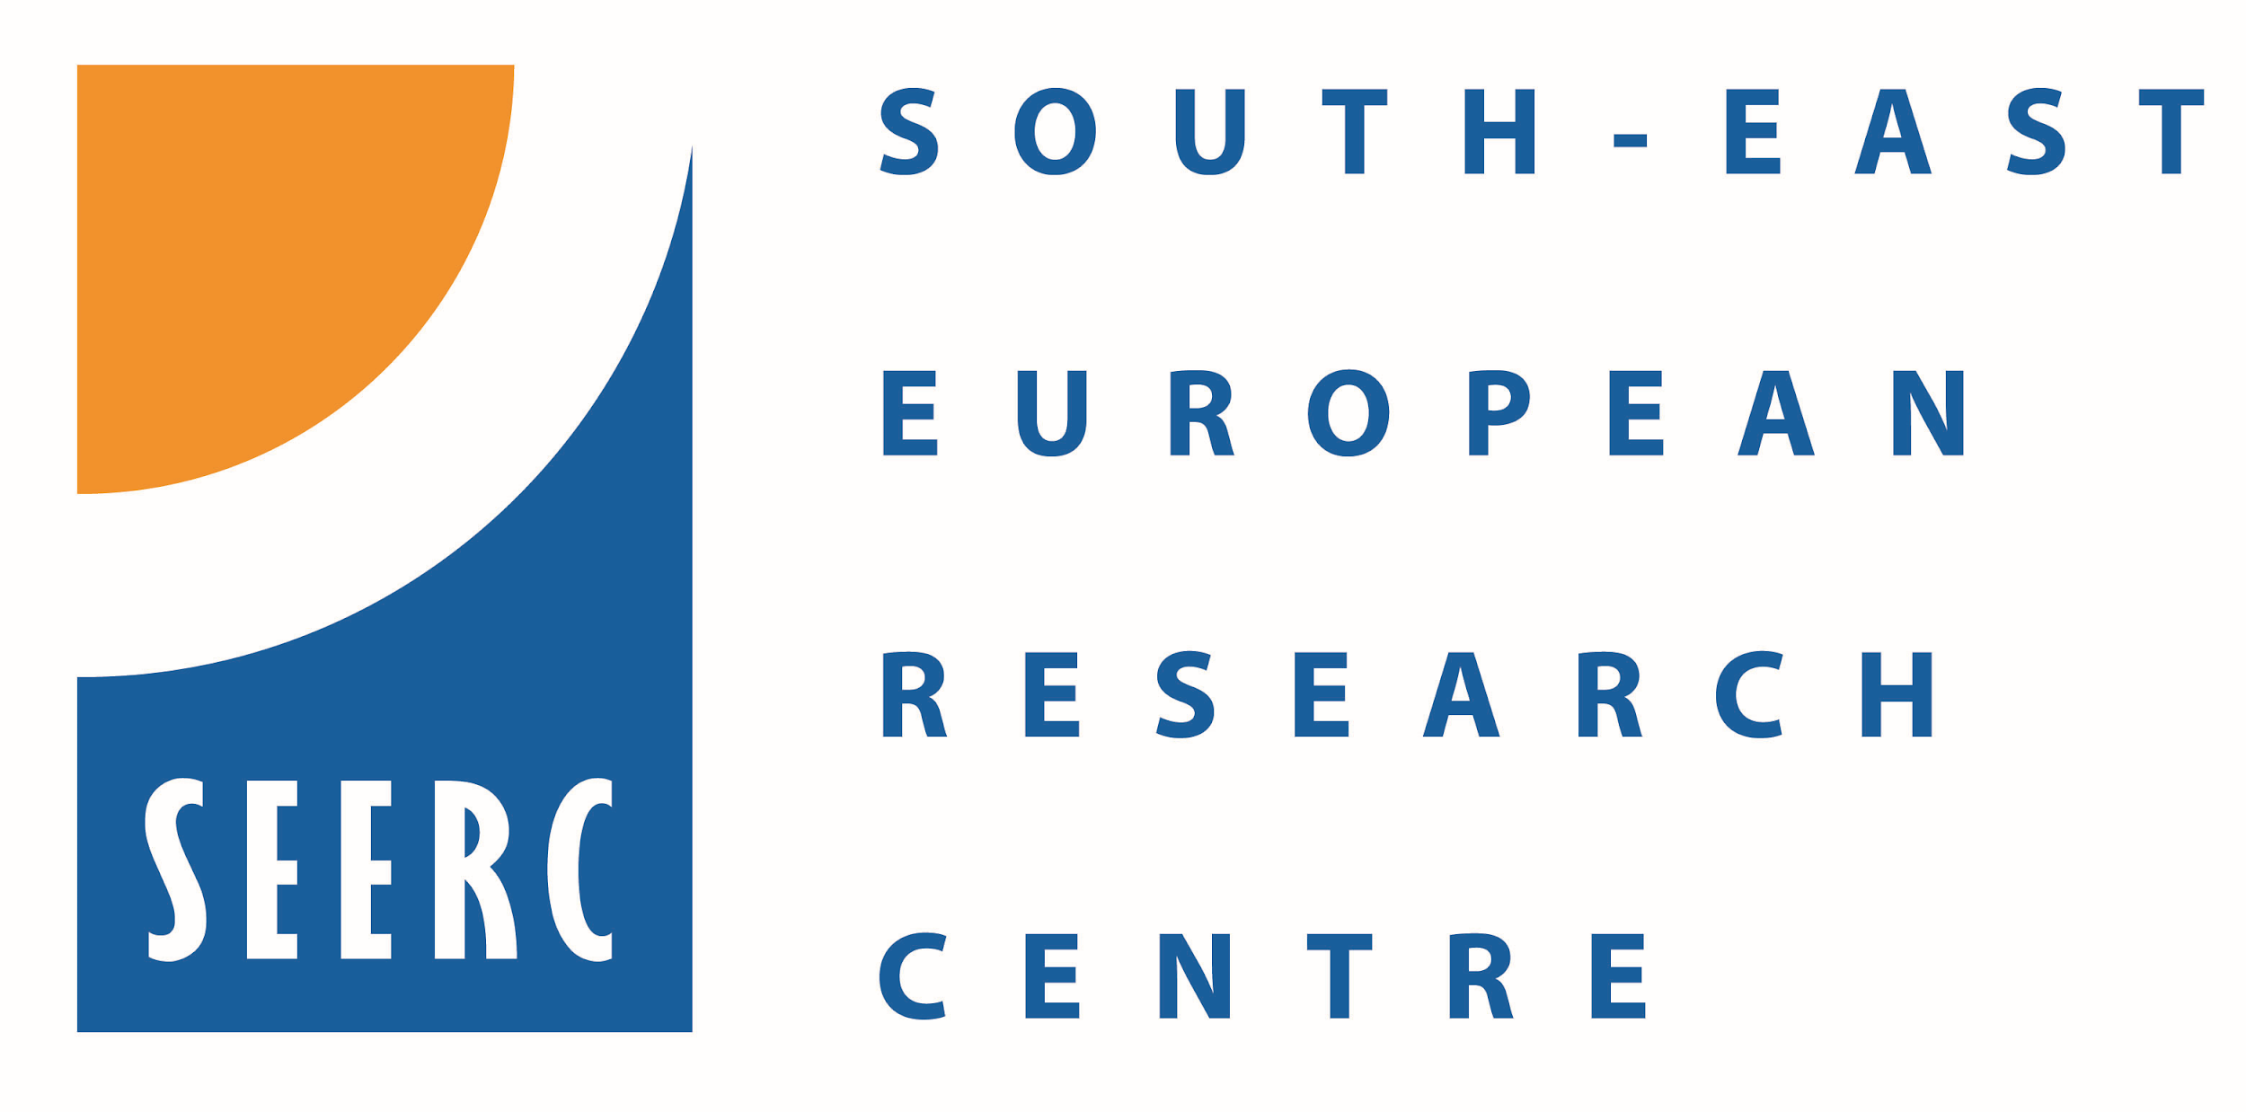
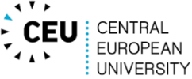

The European Commission support for the production of this publication does not constitute an endorsement of the contents which reflects the views only of the authors, and the Commission cannot be held responsible for any use which may be made of the information contained therein.

MIGRATE is an EU co-funded Jean Monnet Network on the impact of the post-2014 ‘migrant crisis’ on the countries on the Balkan Corridor, as well as, on the future of the EU integration project. The project ran between 2016-2019. You can find more information on MIGRATE’s website at http://www.migrate-project.com/.
The MIGRATE Policy Paper was based on the MIGRATE Network Book, available on the project’s website at http://www.migrate-project.com/deliverables/.
Dr. Dimitris Tsarouhas, Department of International Relations, Bilkent University, Ankara, Turkey Email: dimitris@bilkent.edu.tr.
Parker, O. and Tsarouhas, D. Crisis in the Eurozone Periphery: the Political Economies of Greece, Spain, Portugal and Ireland, London: Palgrave MacMillan.
The Economist (2014) ‘In the queue: the western Balkans and the EU’, 27 September. https://www.economist.com/europe/2014/09/27/in-the-queue.
Beirens, H. (2018) Cracked Foundation, Uncertain Future: structural weaknesses in the Common European Asylum System, Brussels: Migration Policy Institute Europe.

